SafeJourney Suitcase
Jouna Harb, Charbel Ishak
Notre Dame University – Louaize
North Lebanon Campus – NLC
ECCE – Department
^{cmishak@ndu.edu.lb}
^{jwharb01@ndu.edu.lb}

Abstract— This paper presents the proposed "SafeJourney Case" project, aimed at resolving the prevalent issue of luggage loss and theft at airports through the implementation of advanced sensors including ultrasonic sensor, photoresistor sensor and load cell sensor in addition to a smart tag along with an intuitive mobile application. The project integrates a diverse array of technical disciplines, including electronics, software development, and user interface design.
With a primary focus on ensuring a worry-free travel experience for passengers, the project seeks to offer a robust solution that mitigates the risks associated with luggage security during air travel. The report elucidates the project's key objectives, essential prerequisites, inherent design limitations, and a comprehensive risk analysis.
Furthermore, it delineates the strategic project plan, encompassing crucial project activities, a comprehensive cost estimation for the proposed implementation (software and hardware). Jouna Harb and Charbel Ishak collaborate on this project, bringing together their expertise in product development and technology integration to realize the vision of a secure and stress-free journey for every air traveler.

- Introduction

In today's age of frequent air travel, the issue of luggage mishandling and theft continues to plague millions of passengers, adding an unwelcome layer of stress and uncertainty to their journeys. The statistics are telling: according to SITA's latest Baggage Insight Report in May 2023, approximately 26 million pieces of luggage were lost, delayed, or damaged in 2022 alone, translating to nearly eight bags per 1,000 passengers. Issues during transfers between flights were found to be the leading cause, accounting for a significant portion of mishandled baggage [1].
SITA, the multinational information technology company responsible for managing IT systems for 90% of airlines, sheds light on the scale of the problem, revealing that in the first quarter of 2022, major US airlines reported over 684,000 instances of lost and mishandled bags [1]. Furthermore, the Bureau of Transportation Statistics recorded that carriers handled a staggering 393 million bags in 2021, of which over 2 million were reported lost [2].
Airport travel, despite its pivotal role in modern life, continues to be marred by persistent luggage-related issues. The ever-present threat of luggage theft, both during transit and at baggage carousels, remains a significant concern for travelers. Reports of stolen valuables amounting to a staggering $1.2 billion in 2018 underscore the urgent need for effective solutions to safeguard passengers' belongings [3].
Luggage theft, pilfered items from bags after check-in, and the all-too-common mix-up of suitcases at baggage carousels have evolved into a considerable source of inconvenience, frustration, and anxiety for travelers worldwide. According to a news article by CNN, cameras caught airport workers stealing from luggage in Miami International airport [4]. These challenges not only disrupt the smooth flow of journeys but also lead to significant financial losses and emotional distress, leaving a lasting impact on passengers' travel experiences.
To tackle these persistent challenges head-on, the "SafeJourney Case" project proposes a comprehensive approach leveraging advanced smart sensors and a user-friendly mobile application. By prioritizing real-time monitoring, security alerts, and precise location tracking, the project endeavors to curtail the incidence of theft, mitigate the risk of valuable items being stolen from bags, and ensure that travelers never again face the predicament of mistakenly grabbing the wrong suitcase. The SafeJourney Suitcase represents a revolutionary stride toward ensuring a secure and hassle-free travel experience, promising to restore peace of mind and confidence for travelers embarking on their journeys.
This smart suitcase was developed and designed using some sensors (ultrasonic, light, weight sensors) all connected to an ESP32 allowing it to send all the data needed to a well-designed and easy to use mobile application. This helps the traveler to keep updated with any minor inconvenience regarding their suitcase. In addition, a Samsung smart tag is provided in the suitcase in order to track your case wherever it is without the need of Wi-Fi.
- Standards, Constraints, and Requirements Specification
In the pursuit of developing a comprehensive solution to address the persistent issue of luggage security and tracking, a set of stringent standards, constraints, and requirements must be met to ensure the efficient and reliable performance of the proposed SafeJourney Suitcase system. The paramount objective is to significantly increase the security of luggage theft pertaining to unattended bags, while simultaneously providing travelers with an enhanced travel experience. The system design specifications mandate that the solution allow for seamless tracking of luggage, ensuring that travelers can devote their attention to the enjoyment of their journey without the constant concern of misplaced or stolen belongings.
Integral to the system's functionality are the implementation of real-time alerts to promptly notify users of potential threats to the security of their suitcase if it was ever opened. Furthermore, the system is engineered to enable swift and precise location tracking, guaranteeing that in the event of loss or misplacement, users can locate the suitcase. The incorporation of a weight tracking mechanism with an approximate 0.1% error rate serves to assist travelers in avoiding the inconvenience of over packing, facilitating adherence to airline luggage regulations and minimizing additional costs associated with excess baggage.
Additionally, a proactive alert system has been engineered to notify users in the case of opening the case alarming them about a potential theft. Of crucial importance is the seamless tracking of the suitcase's location without relying on having conventional Wi-Fi connected to the suitcase, highlighting the system's capability to operate effectively in various environments and locations, thereby maximizing its usability and practicality for a diverse range of travelers.
In alignment with industry best practices, the project will abide by the standards set forth by prominent organizations such as the Institute of Electrical and Electronics Engineers (IEEE) and the American Society for Testing and Materials (ASTM).

- Functional Decomposition

At the primary level of the SafeJourney Suitcase system, data from various sensors is collected and fed into the central processing unit, referred to as the "SafeJourney Case." The outputs from this central unit are then transmitted to the "Mobile Application," providing users with real-time results and updates.

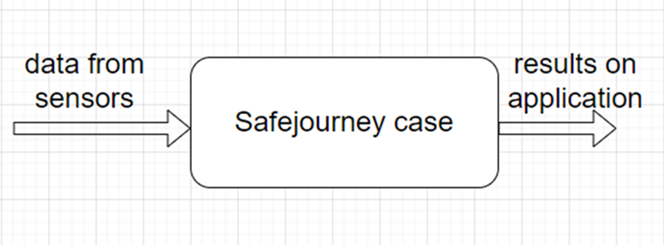
Figure 1: functional decomposition level 0

Diving deeper into the system architecture, the secondary level is composed of four distinct components, 3 of them integrated within the central unit (ESP 32). These 3 components comprise different types of sensors. The first set of sensors involves two ultrasonic sensors, leveraging ultrasound waves to measure distance. The output of these sensors, in the form of distance data, is routed to the ESP 32 for further processing. The second set includes three light-dependent sensors, responsible for reading light conditions and converting them into corresponding voltage data. These voltage outputs are subsequently channeled to the ESP 32 for subsequent analysis.

The third set is a load cell sensor that operates by measuring the force exerted on the luggage and converting it into analog weight data. To ensure precise measurements, the analog data is processed through an HX711 amplifier and analog-to-digital converter (ADC), yielding a digital weight output. This digital weight information is then relayed to the ESP 32 for integration into the overall data processing framework.

Finally, the system incorporates a Samsung Smart Tag, designed to track the location of the luggage. This comprehensive integration of various sensors within the ESP 32 and the Smart Tag enables the SafeJourney Suitcase system to provide users with a cohesive and robust tracking and monitoring mechanism, ensuring the safety and security of their belongings during travel.
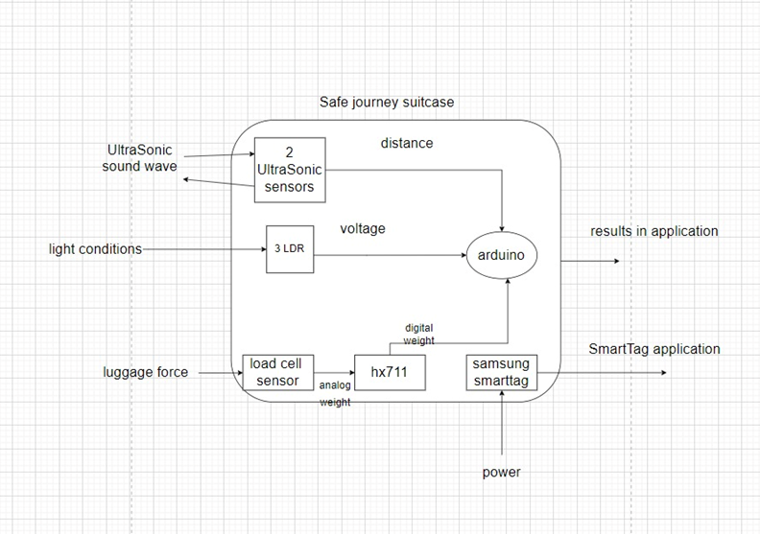
Figure 2: functional decomposition level 1

- Hardware Implementation

In the hardware implementation phase of our project, we have integrated various cutting-edge components to ensure comprehensive security and monitoring of the suitcase. The cornerstone of our system lies in the utilization of a load cell sensor combined with the amplifier HX711, which effectively measures the weight of the suitcase.
Moreover, our approach incorporates the deployment of two ultrasonic sensors, intelligently calibrated to detect any increase in distance, thereby instantly alerting users in the event of unauthorized access or tampering with the suitcase. Recognizing the evolving tactics of theft, especially with the rising instances of fabric suitcase vandalism, we have innovatively integrated light-dependent photoresistors across strategic points within the suitcase. This ingenious addition enables our system to detect any alteration in light conditions in case the suitcase was torn, promptly notifying users in cases where traditional security measures might fall short. The addition of the LDRs was necessary since in the case where the suitcase is torn, the ultrasonic sensors will not detect the distance increasing.
To coordinate the seamless communication between these hardware components and our intuitive software interface, we have seamlessly integrated an ESP32 WROOM DevKit v1, serving as the central nervous system of our operation. This module ensures the real-time analysis of data and facilitates a secure and efficient connection with our dedicated mobile application.
Furthermore, boosting our security measures, we have employed a Samsung Smart Tag, a sophisticated tracking device that enhances the overall safety of the suitcase during travel. This multi-faceted implementation forms the foundation of our hardware infrastructure, promising a comprehensive and foolproof security system for modern-day travelers. In the subsequent sections, we will delve into the complex details of each component and their connections, clarifying their functionalities and seamless interconnectivity within our robust framework.
The process of integrating various components into the ESP32 microcontroller begins with the connection of the load cell to the HX711 module, where the load cell's red wire, representing the excitation voltage, connects to the E+ (Excitation Positive) pin, and the black wire, functioning as the ground wire, links to the E- (Excitation Negative) pin. Furthermore, the white wire, serving as the signal positive wire, is connected to the A+ (Signal Positive) pin, and the green signal negative wire connects to the A- (Signal Negative) pin on the HX711 module.
For the connection between the HX711 and the ESP32, the GND pin of the HX711 is connected to the GND pin of the ESP32, ensuring a common ground reference. The VCC pin of the HX711 is linked to the Vin pin of the ESP32 to provide a stable power supply. The DT (Data) pin of the HX711 is connected to D19 (GPIO 19) of the ESP32, facilitating data communication between the two components, while the SCK (Serial Clock) pin of the HX711 connects to D18 of the ESP32, ensuring synchronized data transmission.
In the case of the two ultrasonic sensors, both sensors have their GND pins connected to the GND pin of the ESP32, while their VCC pins are connected to the Vin pin. The trigger and echo pins of the first ultrasonic sensor are linked to D26 and D27, respectively, while the corresponding pins of the second ultrasonic sensor connect to D22 and D23, enabling distance measurement and obstacle detection.
Regarding the photoresistors, their LDR pins are connected to the Vin pin of the ESP32, with the other pin connected to a 220-ohm resistor. This resistor's other pin is linked to D2 of the ESP32, and its remaining pin is connected to GND. All photoresistors utilized in the project follow the same configuration, connecting to the same pins of the ESP32, facilitating light intensity measurements and ambient light sensing.

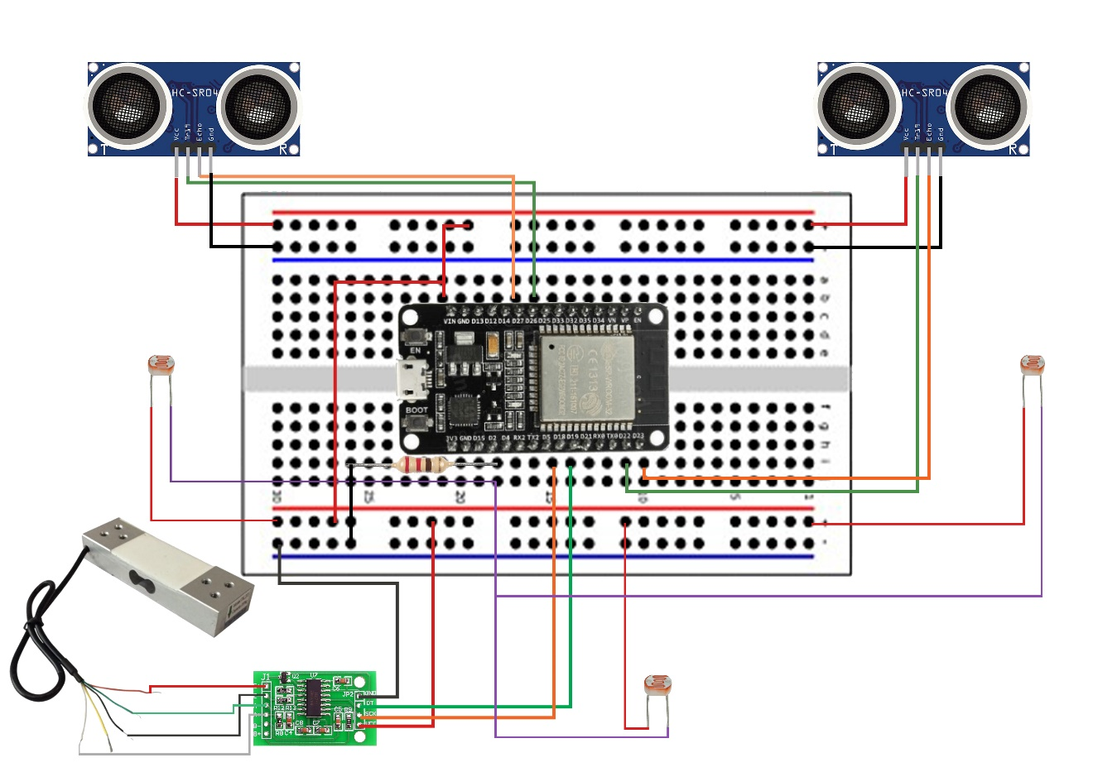
Figure 3: the full circuit

While we were building our prototype, we wanted to place the load cell with a strong base so it doesn’t break with the weight pressure on it. So, we decided to put an Aluminum base that can fit inside the suitcase on the bottom without taking much space of the suitcase. We strongly bolted this base to the case then we firmly fixed the load cell onto this base. Next, we placed a wooden plate on top of it with 2 hex nuts leaving space between the plate on the load cell, so they don’t touch preventing us from getting accurate measures.

Although, when we were trying to calibrate the load cell, the plate was bending and touching the load cell and consequently we weren’t getting an accurate number when the weight was above 6kg. That’s why we decided to add 2 metal bars above the metal hex nuts, so the plate won’t bend and touch the load cell.

For the LDRs, we distributed them in the case as follows, one on the left side of the suitcase, one on the top and one on the right slightly above the wooden plate. We fixed these LDRs using strong electrical tape.

As for both ultrasonic sensors, they are on both sides of the bottom of the lid compartment of the suitcase. We stitched them to the fabric of the suitcase and fixed them firmly with electrical tape.

All the other components, like the breadboard, the ESP32, The HX711 are all placed at the bottom of the suitcase next to the load cell.

- Software application

In the software application section, our initial strategy involved utilizing the Arduino IDE software and establishing a connection between our system and the Flutter application through the serial communication method. However, we encountered challenges with this approach. To address these issues, we transitioned to an alternate methodology by employing the Arduino IDE and establishing connectivity with the Flutter application using the Bluetooth Low Energy (BLE) protocol. This shift allowed us to overcome the encountered obstacles and provided a more robust and effective means of interaction between our hardware system and the Flutter application, ensuring smoother data transmission and communication.

Regarding the Arduino IDE code, it sets up a Bluetooth system in an ESP32 microcontroller to monitor a suitcase. It measures weight using a sensor, detects light using a light sensor, and calculates distances using ultrasonic sensors. The data collected (weight, light intensity, distances) is made available via a Bluetooth connection so that a phone or other device can read it. Additionally, it includes features like auto-restart when the connected device disconnects and periodic updates of sensor data. This setup could be used for a smart suitcase that reports its weight, light exposure, and whether it's open or closed through a Bluetooth connection.

As for the flutter code, when we first create a new project in flutter, many files including the 3 files called “pubspec.yaml” and “AndroidManifest.xml” and “main.dart” are automatically created. We added 2 files: “Bluecall.dart” and “noti.dart”.

“pubspec.yaml” we define our dependencies: flutter_blue, permission_handler, and flutter_local_notifications. We also add assets for the background image used in the app. We the use flutter pub get command to install all the libraries needed.
The file “Noti.dart” is responsible for the notification settings and it uses two techniques:
initialize(): Prepares the system for notifications.
showNoti(): Displays a message on the phone's display.

On the other hand, “bluecall.dart”, sets up the necessary variables and instances required for managing Bluetooth-related operations, such as device discovery, connection, and communication with specific characteristics of a Bluetooth device. It parses the received data string from the notification (which are the light and distance flags that are continuously being sent from the esp32), divides it into discrete readings, and modifies two variables (lightData and distanceData) according to the received light and distance values. Additionally, it calls the onDataReceived() method, which updates the presented information by informing the user interface of the new data.

Moving on to “AndroidManifest.xml”, in this file, we ask for permissions that are needed for Bluetooth to work. And then we add the meta-data that are needed for the notification to work. We should make sure here that android:value is the same as the channel_id which is defined in the showNoti function in the Noti.dart file.

Finally for the “main.dart” which is the code that integrates everything together. It serves as the main interface for the application's home page, handling Bluetooth device scanning, notifications, and managing the state related to these functionalities. It interacts with the Bluecall class for Bluetooth-related tasks and utilizes the flutterLocalNotificationsPlugin for local notification management within the app.

It also creates a timer that checks every 10 seconds if there's a need to send notifications based on Bluetooth data. It first stops any ongoing timer to prevent conflicts, then sets up a new timer to repeat every 10 seconds. Within this timer, it looks at whether notifications are turned on and if either the light or distance data from Bluetooth shows something important (like a '1' indicating an alert). If there's something crucial, it sends the corresponding notification, but if the data doesn't indicate an issue, it stops the timer and makes sure that no notification has been sent, keeping everything in sync with the changing Bluetooth information.

A drawer is created with ListTitle that has many options for the user to check weight, light, distance and smarttag.

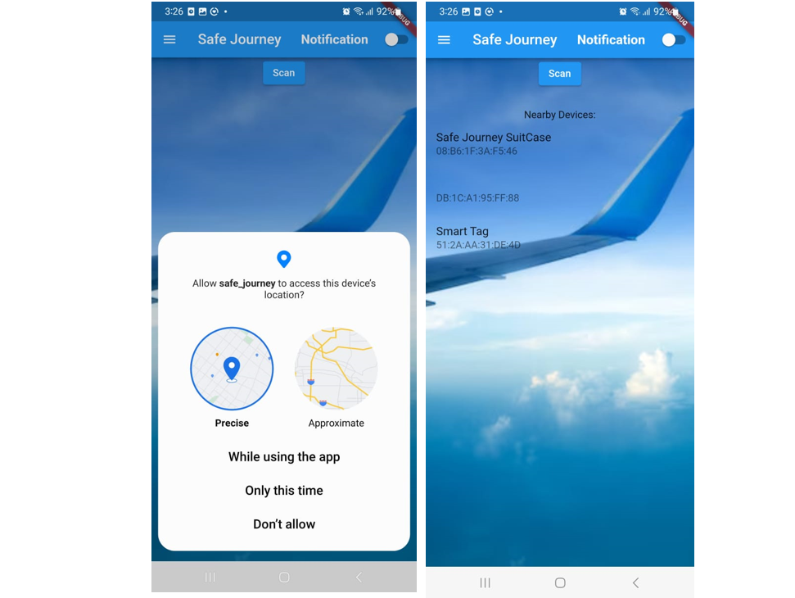
Figure 4: some screenshots from the application

Figure 5: GPU applications

- conclusion

In conclusion, the SafeJourney Suitcase project represents a culmination of planning, dedicated teamwork, and innovative problem-solving. Through a strategic one-year project, We undertook the challenge of revolutionizing luggage security and tracking. From the initial phase of a full research from January 2023 to the sensor procurement during the summer months to the rigorous testing and integration of various components in September, October and November, each stage was met with precision and dedication.

Together, our knowledge of both software and hardware development ensured a well-rounded strategy. The methodical allocation of responsibilities and the coordinated efforts resulted in the successful development of a comprehensive and user-friendly system that promises to redefine luggage security and enhance the travel experience. Despite facing challenges inherent in innovative projects, the team persevered and delivered a functional and reliable solution by the November deadline.

Looking ahead, the SafeJourney Suitcase stands as a testament to innovation in the realm of travel technology. Its potential to increase luggage security, track belongings, and provide travelers with peace of mind speaks volumes about its relevance in modern travel.

References
- SITA. (2023, May). Baggage Insight Report. Retrieved from https://www.sita.aero/resources/surveys-reports/baggage-it-insights-2023/
- Bureau of Transportation Statistics. (2021). FAQ: Is Lost Luggage Always Found? Retrieved from https://lovethemaldives.com/faq/is-lost-luggage-always-found
- Forte, J. (2021, June 9). Airport security now warning baggage thefts as travel numbers pick up. Retrieved from https://www.newsnationnow.com/us-news/airport-security-now-warning-baggage-thefts-as-travel-numbers-pick-up/
- Zamost, S., Griffin, D., & Devine, C. (2015, September 15). Hidden cameras reveal airport workers stealing from luggage. CNN. Retrieved from https://edition.cnn.com/2015/04/13/us/airport-luggage-theft/index.html

